

**COMP 5350**

**Digital Forensics**

**Hands-on Activity#** 2

Kate Moreland

kem0149

10/6/25

# Executive Summary

The following report shows the process of extracting files from a disk image. The files were recovered from a NTFS partition that led to the location and name of the criminal.

|  |  |
| --- | --- |
| Q1. Specify the number and type of partitions on the disk image. | There is 1 partition on the disk image. It is an NTFS partition. |
| Q2. Specify the number of files, file name, and file size of each file on the partition. | There 3 files are innocent_cat.jpg, for_ghost.txt, and passphrase.txt. The size of innocent_cat.jpg is 1024 bytes on partition 1. The size of for_ghost.txt is 1024 bytes on partition 1. The size of passphrase.txt is 1024 bytes on partition 1. |
| Q3. Specify the starting and ending byte offset location of each file on the partition. | innocent_cat.jpg: Starting () Ending ()  for_ghost.txt: Starting() Ending ()  passphrase.txt: Starting() Ending() |
| Q4. Provide a thorough analysis of the recovered files: Determine the contents of these files to understand the objective, the plan, and any other critical information about the hack. | The first file that was recovered is called innocent_cat.jpg. This is a picture of a cat. This will be important later. The second file that was recovered is called for_ghost.txt. This txt file says that you will have to use stego skills to find a hidden file. The third file that was recovered from passphrase.txt. This txt file contains the following text “MTIzNA==”. This is Base64 encoded and it translates to 1234. Finally, I ran steghide to discover the fourth file within the innocent_cat.jpg. This reveals the real name of Shadow and his address. |

# Table of Contents

Executive Summary 2

Table of Contents 4

List of Figures 5

List of Tables 8

1 Detailed Analysis of Partition Allocation 9

Partition 1 9

Detailed Analysis of the Recovery Process 10

File 1 11

File 2 15

File 3 19

Steg 24

3 Description of Analysis Techniques Utilized 26

4 Results and Discussion 26

5 Conclusions and recommendations 27

6 Acknowledgements 27

7 AI Use Statement 27

8 References 27

# List of Figures

innocent_cat.jpg

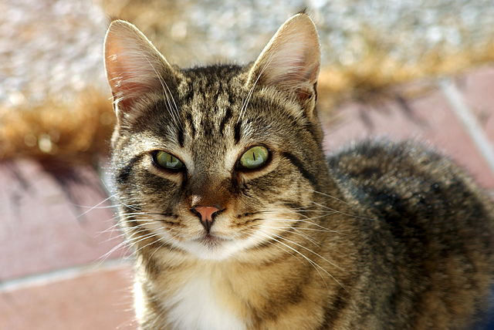

for_ghost.txt

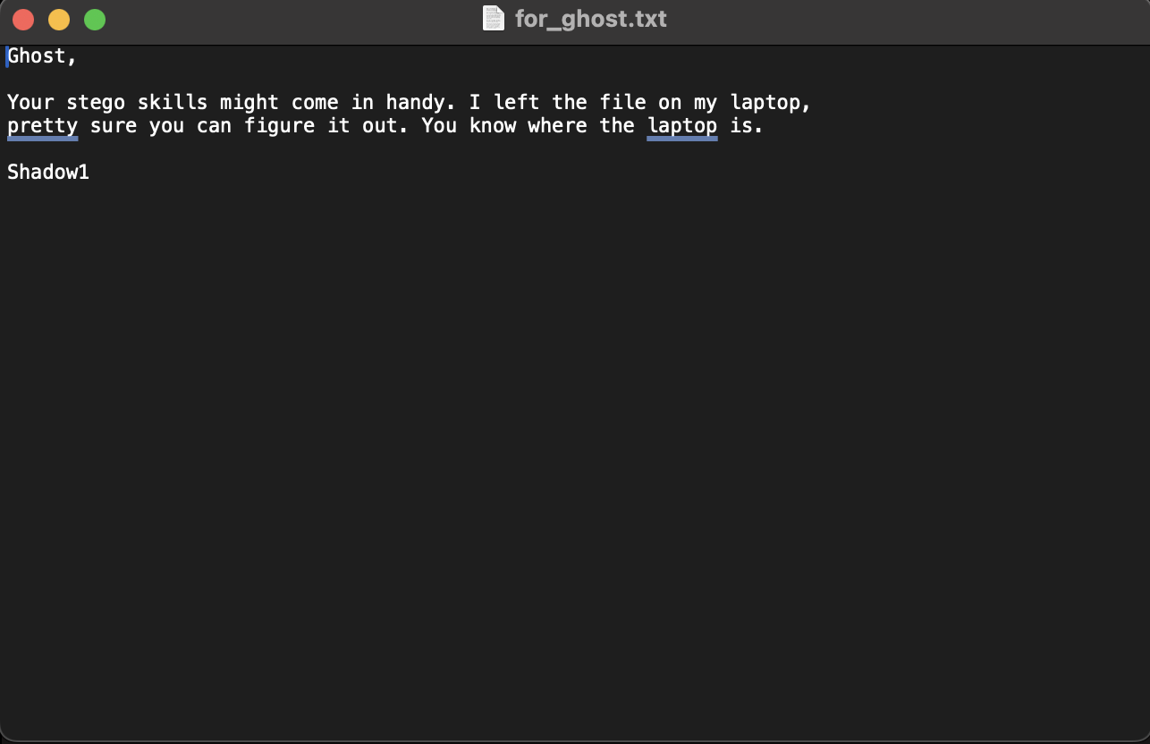

passphrase.txt

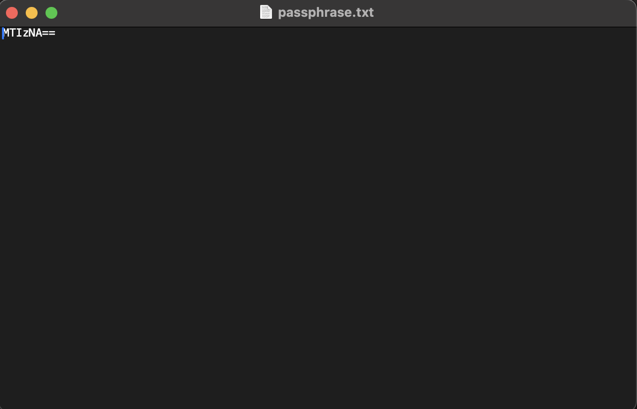

secret.txt

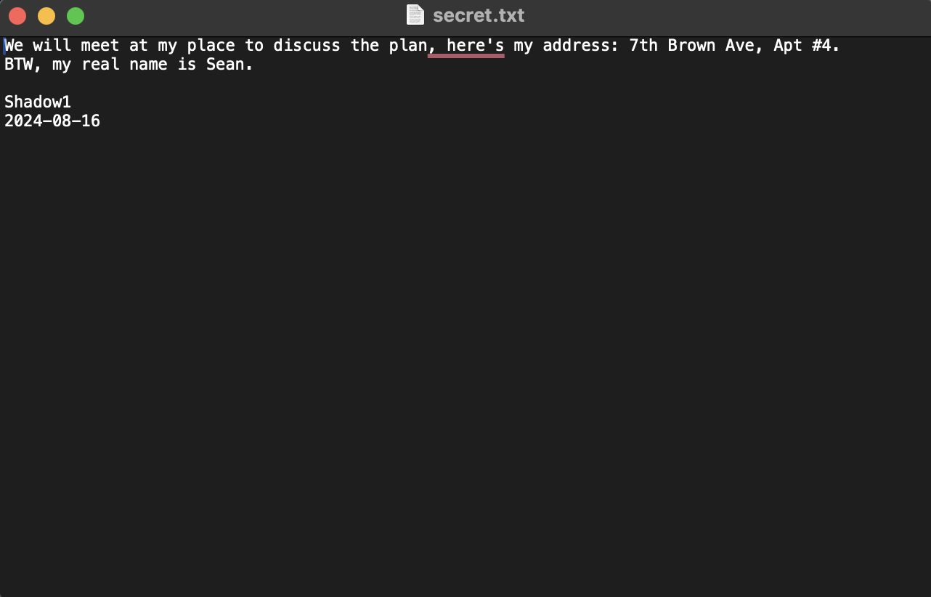

# List of Tables

Files with commands for both hexdump and dd

|  |  |  |
| --- | --- | --- |
| File | Confirmation Command | Recovery Command |
| innocent_cat.jpg | hexdump ShadowLaptop.dd -s $(( 133120*512 )) -n $(( 120*512 )) | dd if=ShadowLaptop.dd of=innocent_cat.pdf bs=512 skip=133120 count=120 |
| for_ghost.txt | hexdump ShadowLaptop.dd -s $(( 133240*512 )) -n $(( 8*512 )) | dd if=ShadowLaptop.dd of=for_ghost.txt bs=512 skip=133240 count=8 |
| passphrase.txt | hexdump ShadowLaptop.dd -s $(( 133248*512 )) -n $(( 8*512 )) | dd if=ShadowLaptop.dd of=passphrase.txt bs=512 skip=133248 count=8 |

File name with the starting and ending offset

|  |  |  |
| --- | --- | --- |
| File Name | Starting Offset | Ending Offset |
| innocent_cat.jpg | 68157440 | 68215932 |
| for_ghost.txt | 68218880 | 68219030 |
| passphrase.txt | 68222976 | 68222985 |

# 1 Detailed Analysis of Partition Allocation

There is 1 partition in the image. It is NTFS. You can see that the sectors before the partition are 2048 because that is where the partition starts. Below is an image of the partition with where it starts and ends.

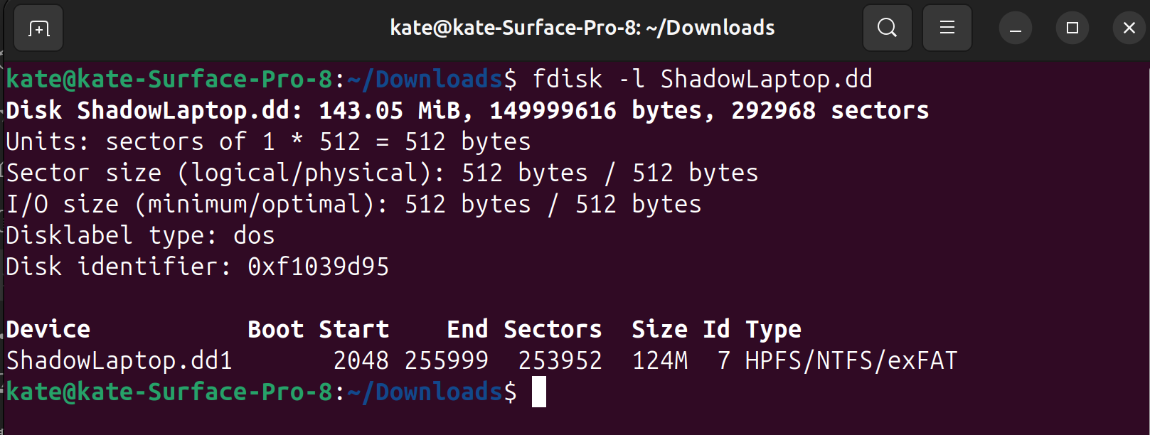



# Partition 1

To find the information about the NTFS partition, we need to use Disk Editor. It starts at 2048. The bytes/sec is 512. The sec/cluster is 8. There are 0 reserved sectors. The $MFT Cluster Start is 4 and the $MFTMirr Cluster Start is 15871. The # System $MFT Records is 27 as stated in the assignment instructions. The $MFT Record Size is 1024 that is stated in the assignment.

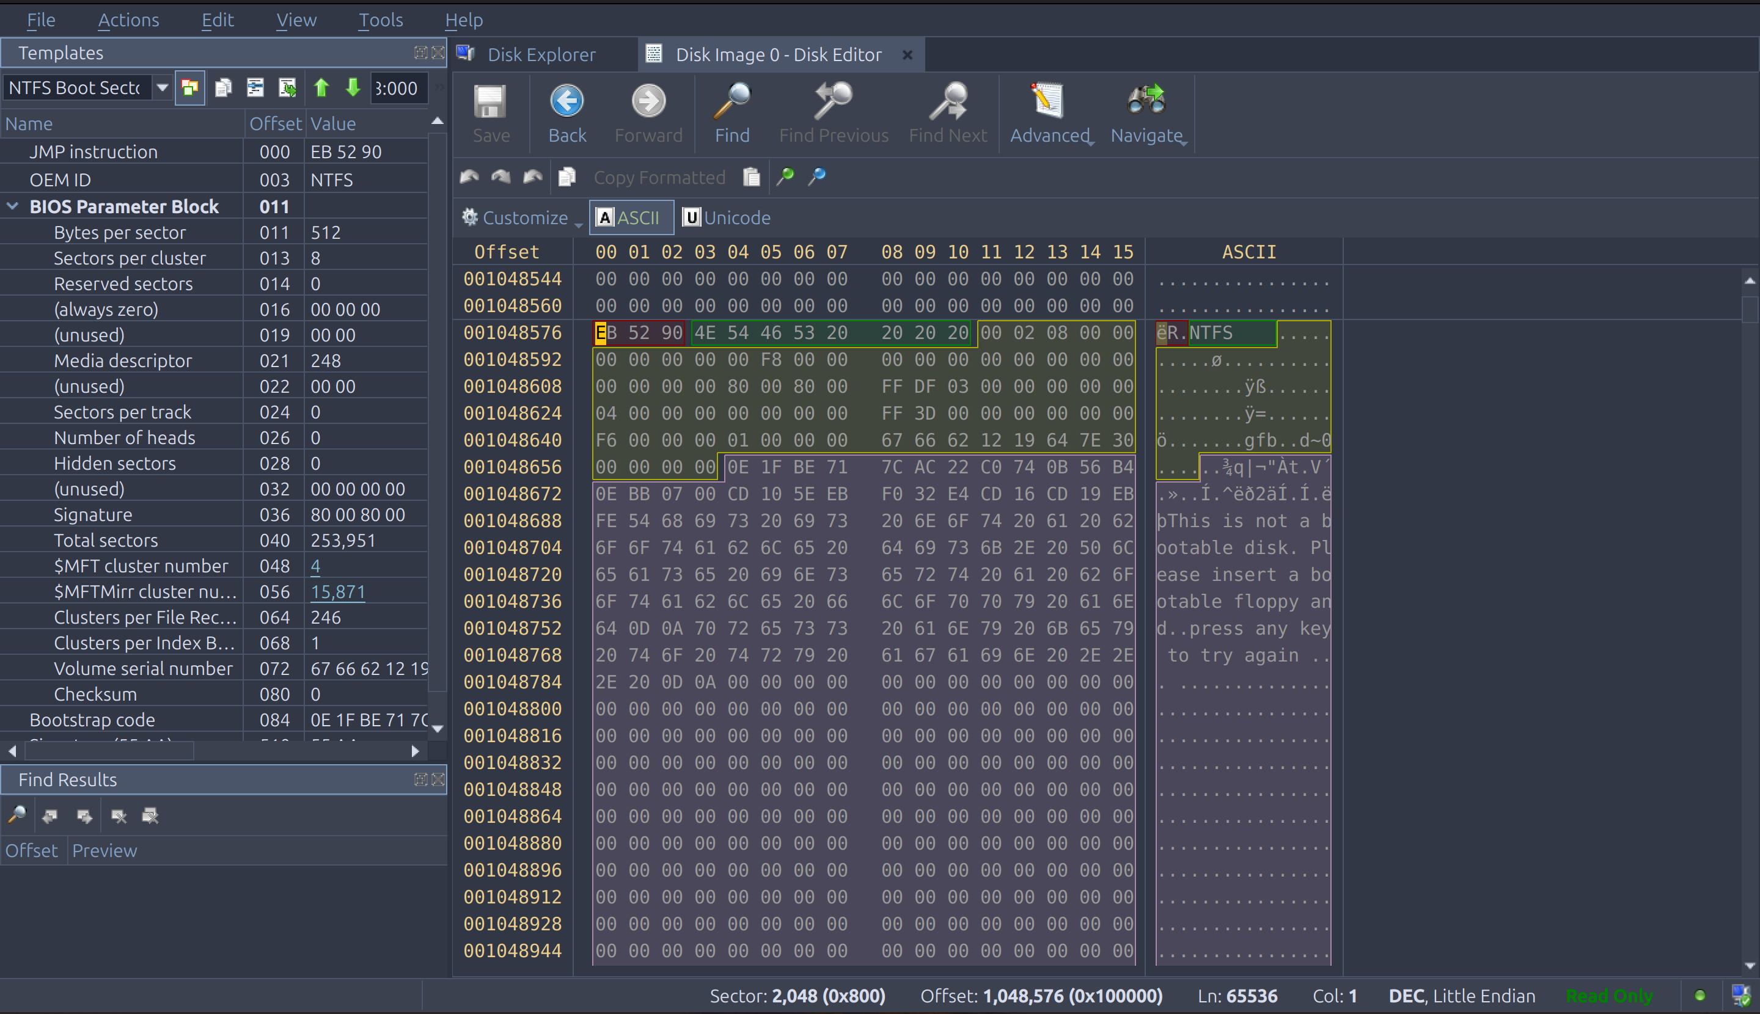



## Detailed Analysis of the Recovery Process

After the disk information is analyzed, look at the MFT. The MFT shows the status of the file, the size of the file, and the characteristics of the file. Let’s first take a look the the MFT System Records it is at 2080 because the MFT Cluster Start is 32 sectors long and 2048 + 32 = 2080. We can find the allocated sectors of by multiplying MFT Record Size * System $MFT Records / Bytes/Sec. So it would be 1024 * 27 / 512 = 54.

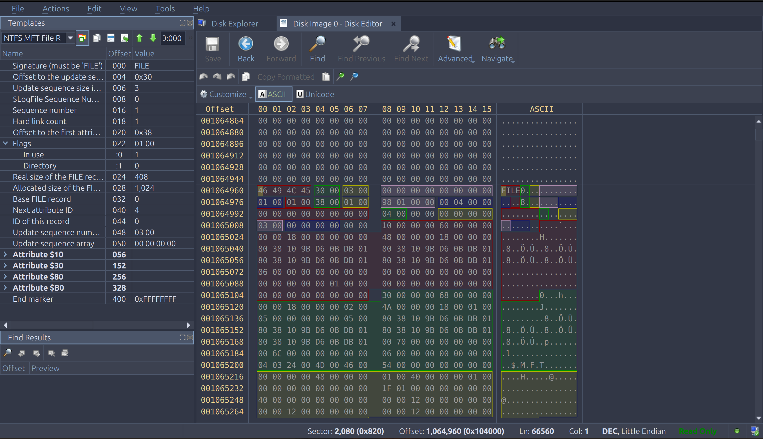



## File 1

I calculated the sectors to partition by adding up the sectors before partition, MFT Cluster Start, and MFT System Records. It is 2048 + 32 + 54 = 2134. Go to that sector in Disk Editor. By looking at the file description, it shows that it is in use by looking at the in-use flag.

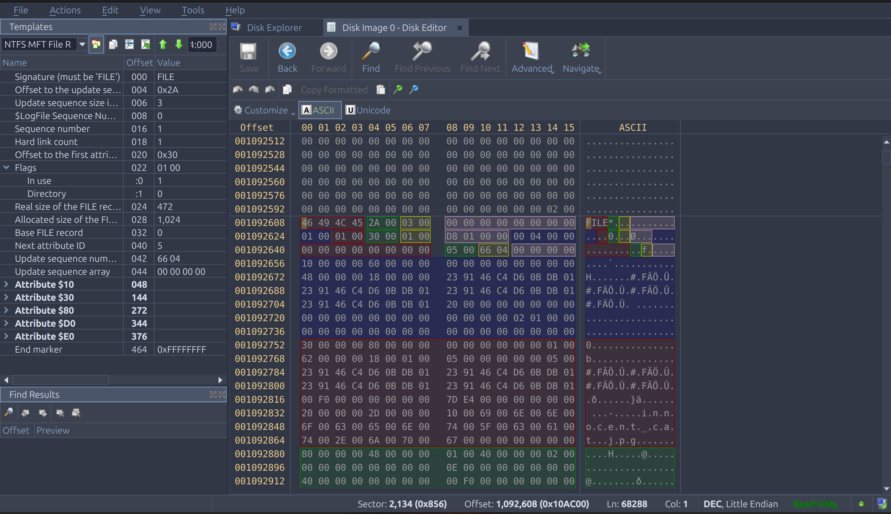



If you look in the $30 section, you can find the file name. It is innocent_cat.jpg.

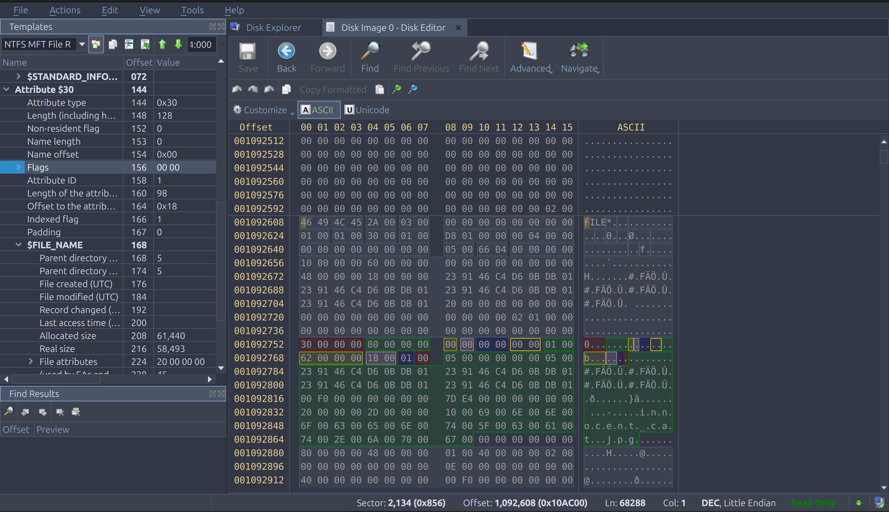



If you look under the $80 section, the Non-Resident flag is 1. The allocated size is 61440. Also look at the real size and it is 58493. The 1st cluster is 16384. Calculate the 1st sector by multiplying the 1st cluster by the sec/cluster. It is 16384 * 8 = 131072. Add the disk offset to the 1st sector to get the 1st sector + disk offset = 133120. The number of clusters is 15. The number of sectors is the number of clusters by the sec/cluster. It is 15 * 8 = 120. The first VCN is 0 and the last VCN is 14.

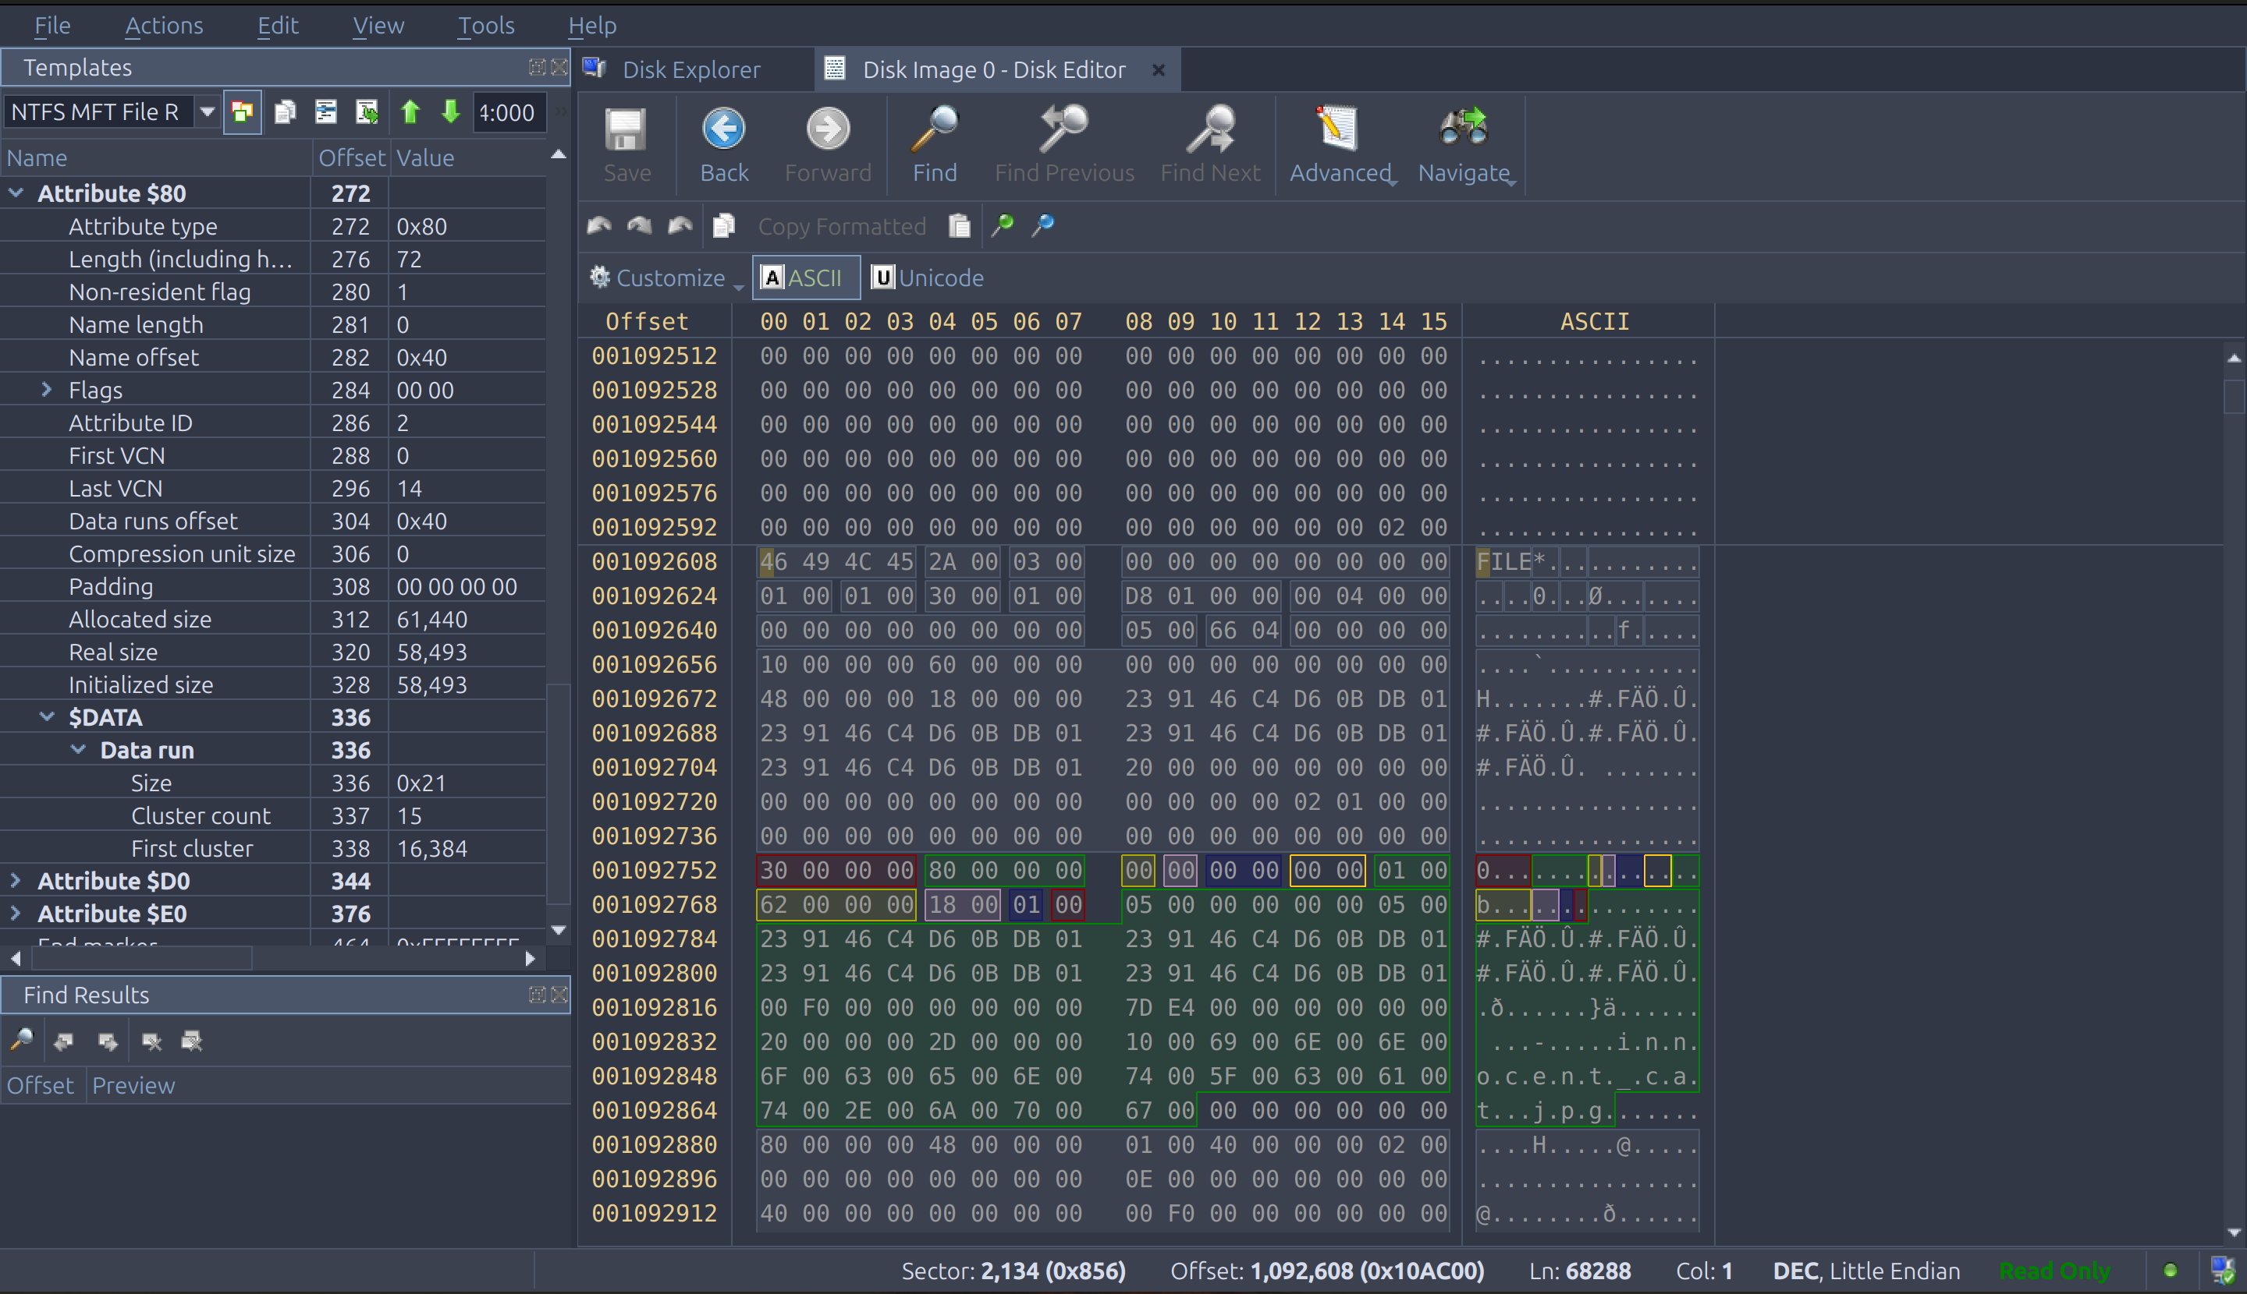



Now it is time to carve the file. To find the amount to skip use the 1st sector + disk offset and the count is the number of sectors.

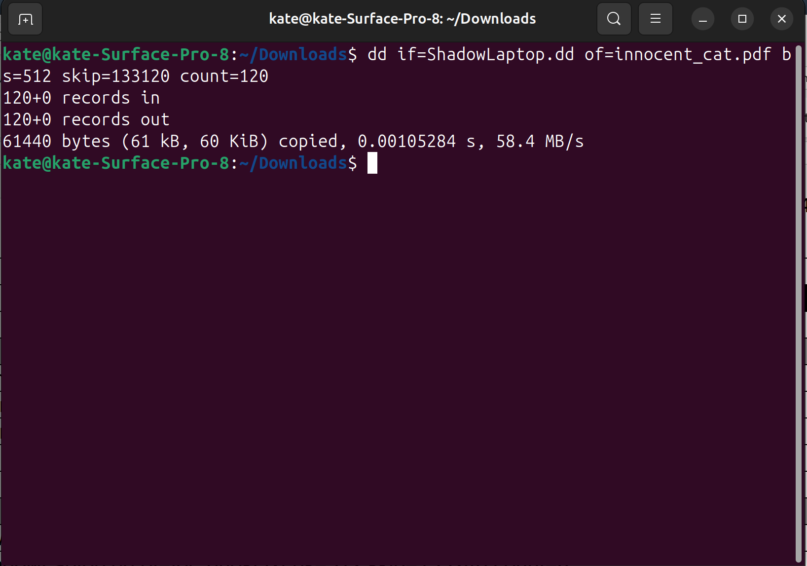

Here is the file that is carved.



## File 2

To calculate the sectors to partition, add up the sectors before partition, MFT Cluster Start, MFT System Records, and the previous file. It is 2048 + 32 + 54 + 2 = 2136. Go to that sector in Disk Editor. By looking at the file description, it shows that it is in use by looking at the in-use flag.

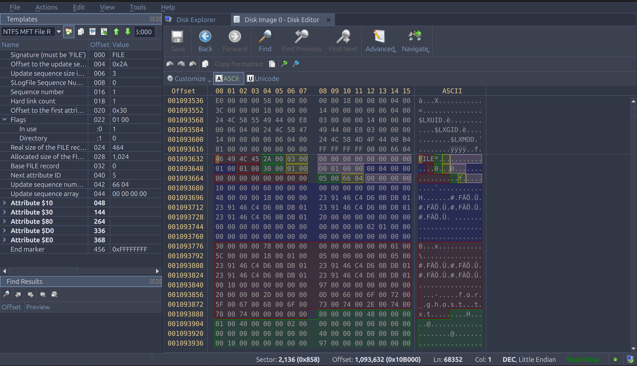



Look in the $30 section, for the name of the file. The name of the file is for_ghost.txt.

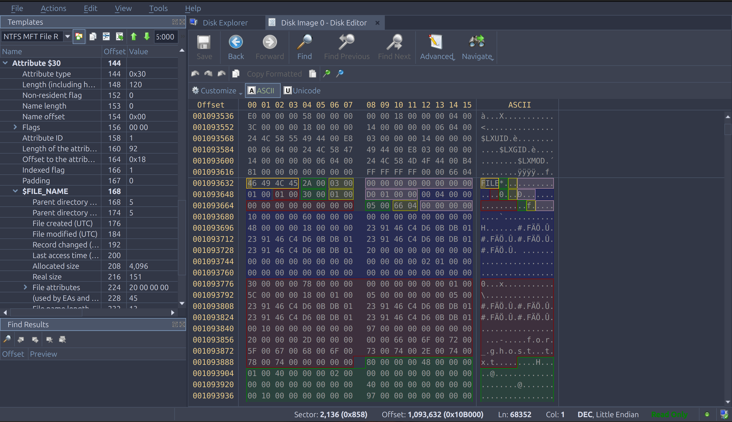



In the $80 section, the non-resident flag is 1. The allocated size is 2048. Also, the real size is 151. The 1st cluster is 16339. Calculate the 1st sector by multiplying the 1st cluster by the sec/cluster. It is 16339 * 8 = 131192. Add the disk offset to the 1st sector to get the 1st sector + disk offset = 133240. The number of clusters is 1. The number of sectors is the number of clusters by the sec/cluster. It is 1 * 8 = 8. The first VCN is 0 and the last VCN is 0.

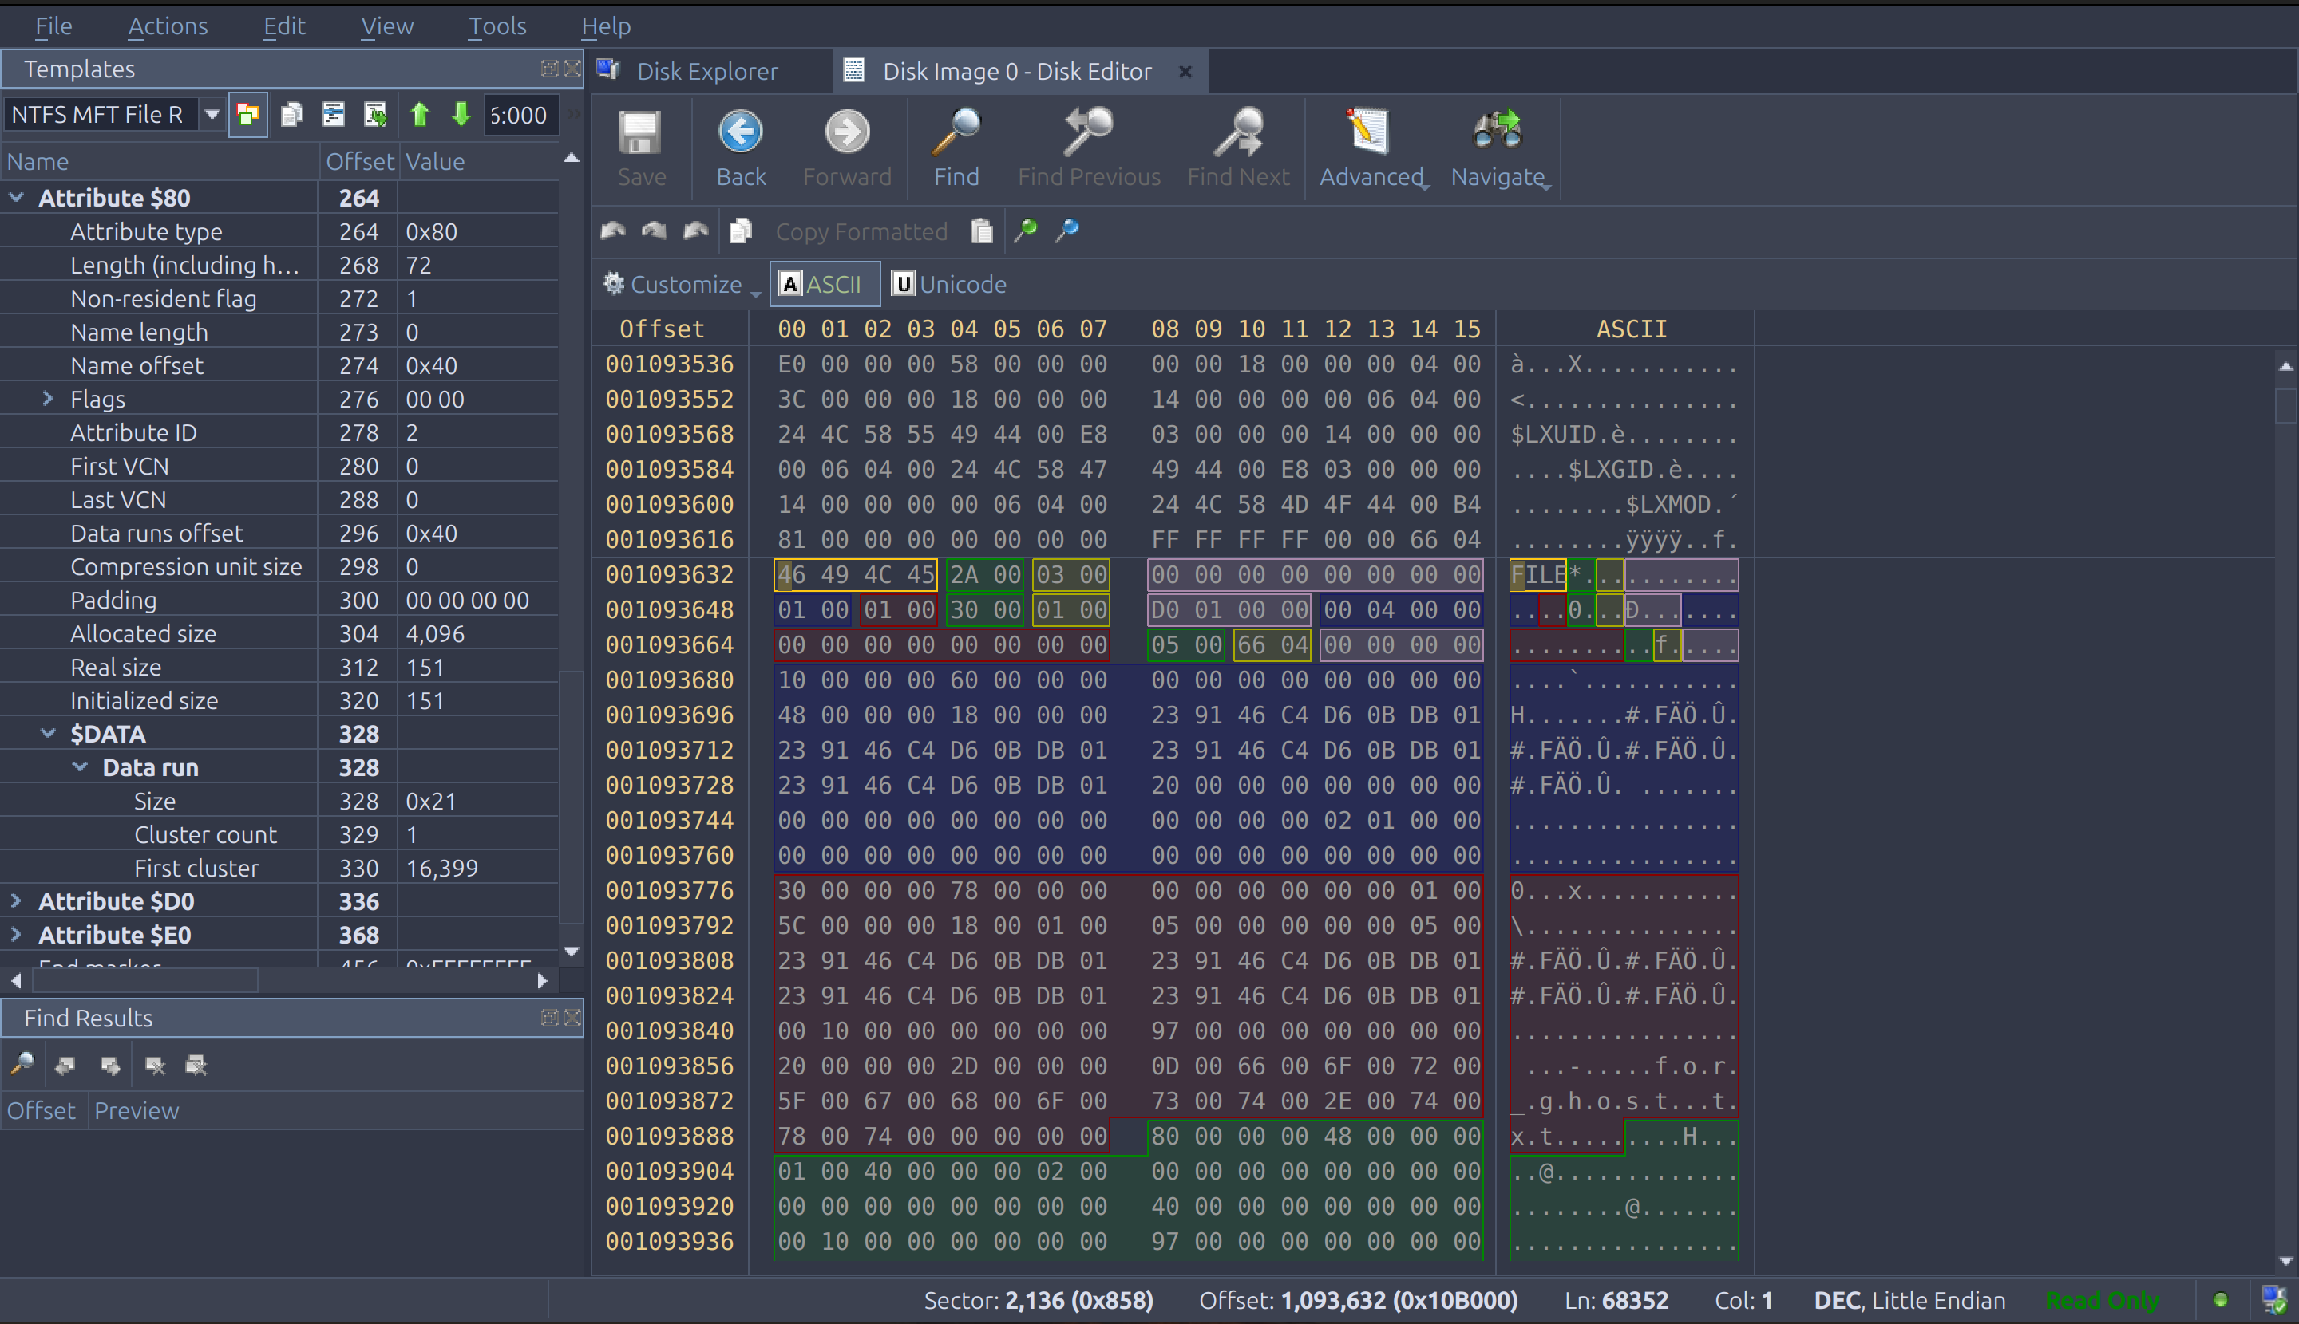



Now to carve the file use the dd command. To find the amount to skip use the 1st sector + disk offset and the count is the number of sectors.

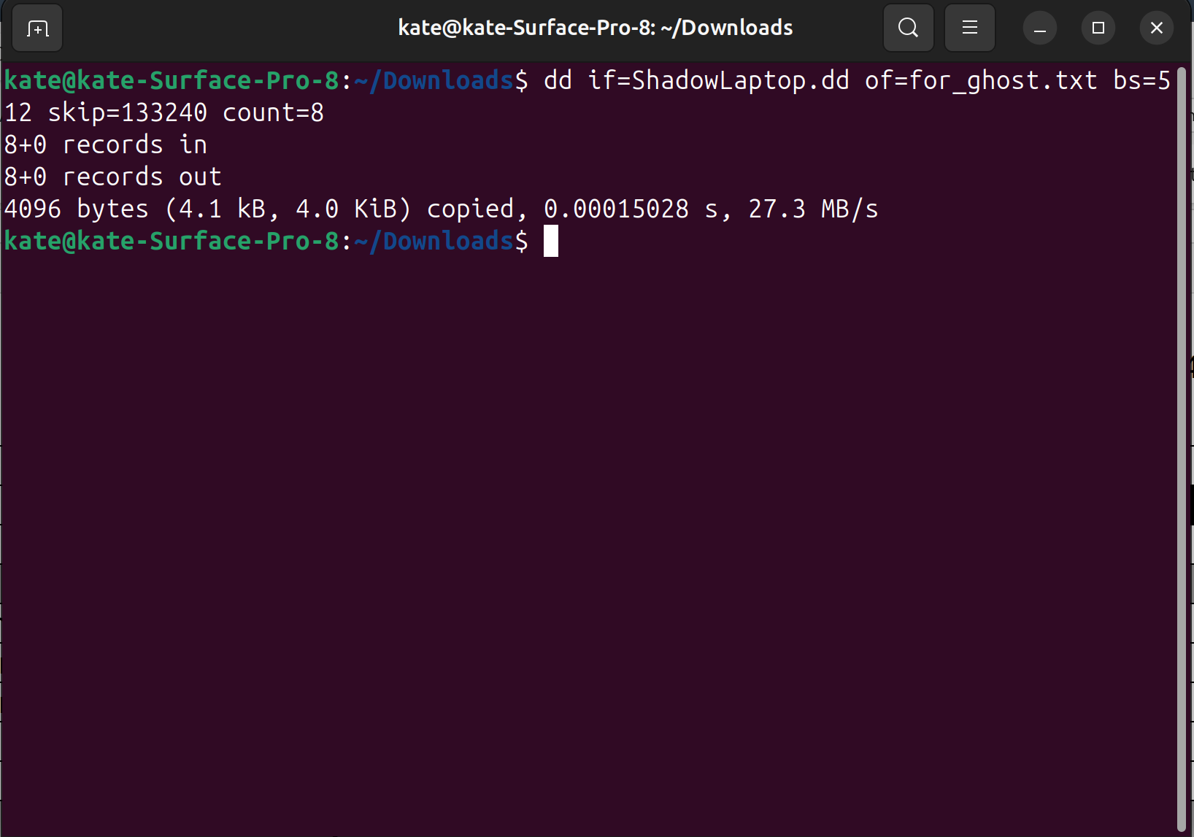

Here is a picture of the file that was carved.



## File 3

To calculate the sectors to partition, add up the sectors before the partition, MFT Cluster Start, MFT System Records, and the previous files. It is 2048 + 32 + 54 + 2 + 2 = 2138. Go to that sector in Disk Editor. By looking at the file description, it shows that it is in use by looking at the in-use flag.

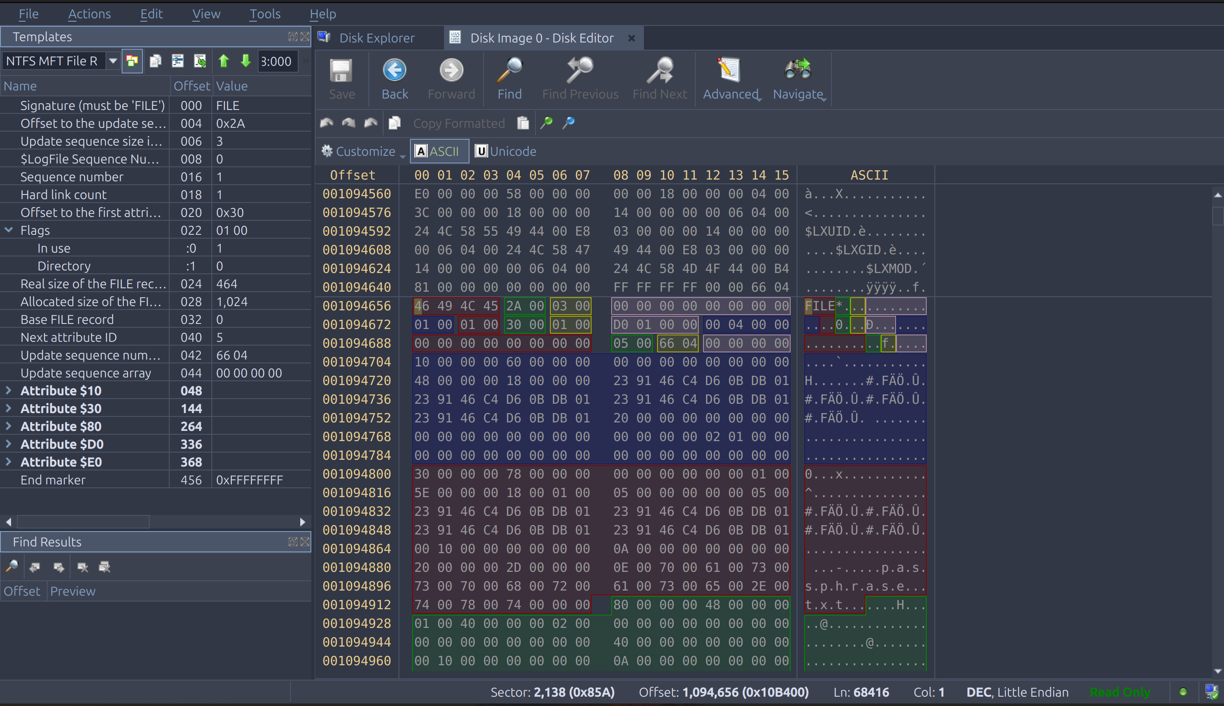



Look in the $30 section, for the name of the file. The name of the file is passphrase.txt.

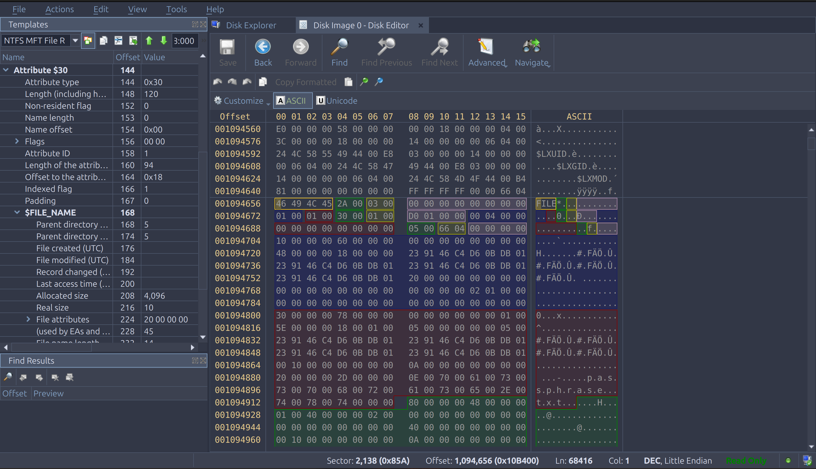



In the $80 section, the non-resident flag is 1. The allocated size is listed as 4096. Also, the real size is 10. The 1st cluster is 16400. Calculate the 1st sector by multiplying the 1st cluster by the sec/cluster. It is 16400 * 8 = 131200. Add the disk offset to the 1st sector to get the 1st sector + disk offset = 133248. The number of clusters is 1. The number of sectors is the number of clusters by the sec/cluster. It is 1 * 8 = 8. The first VCN is 0 and the last VCN is 0.

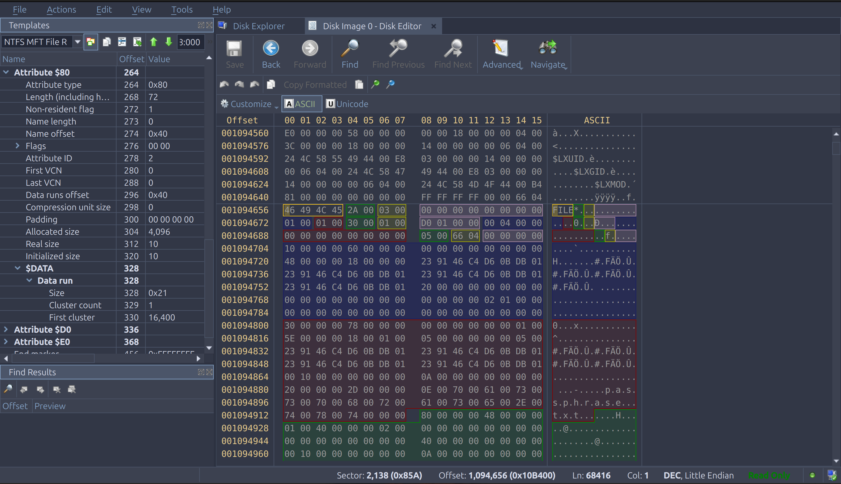



Now to carve the file use the dd command. To find the amount to skip use the 1st sector + disk offset and the count is the number of sectors.

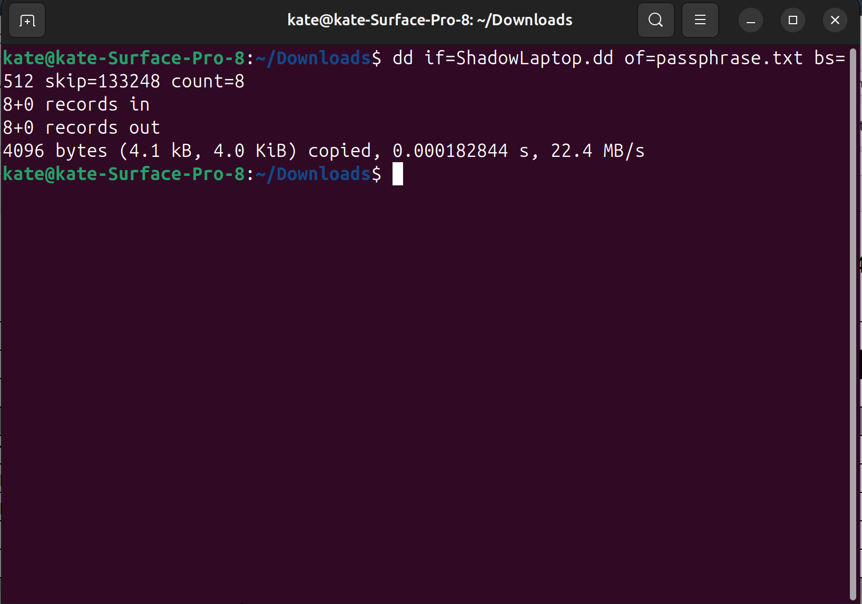

Here is a picture of the file that was carved.



This is encoded in Base64. Translate it in the terminal to see what it says. Below is the command I used to find it:

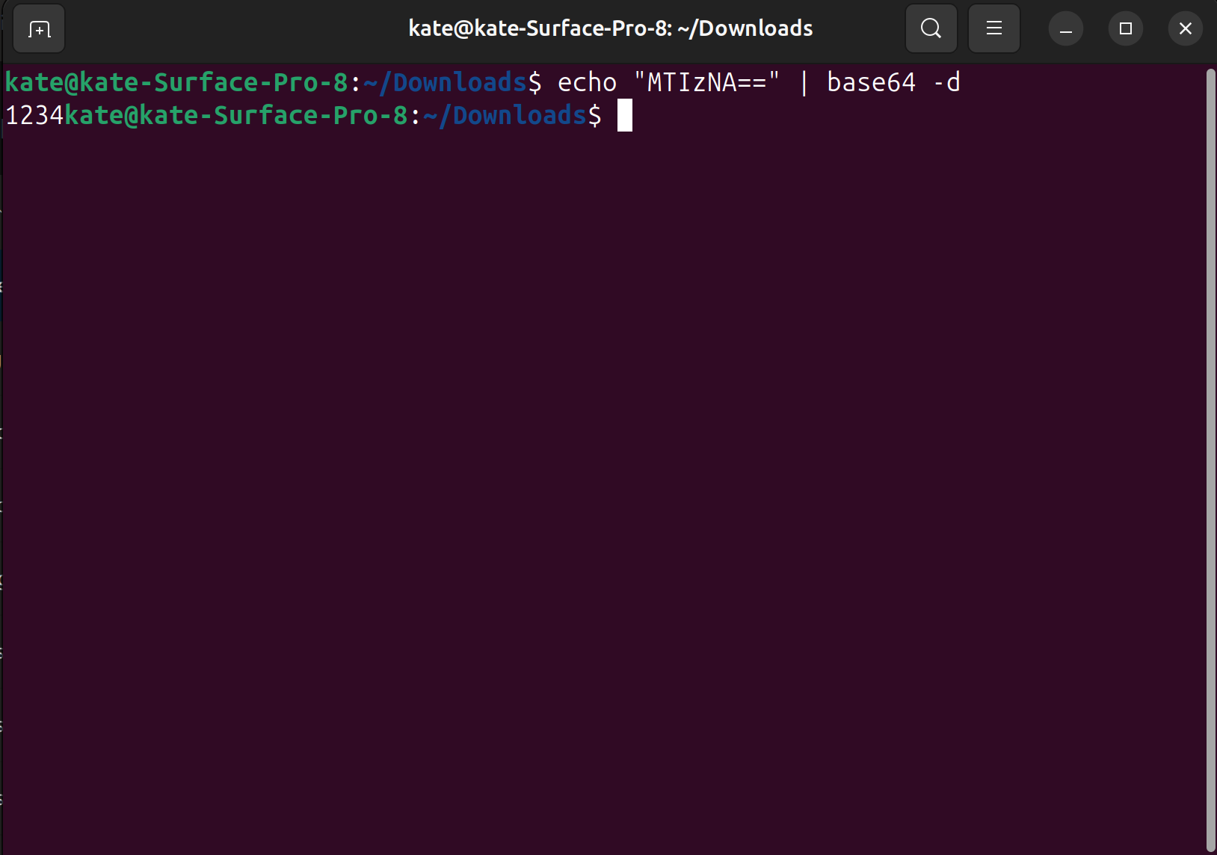

The result is 1234. So 1234 is the passphrase that is going to be used.

## Steg

Earlier in the process, the for_ghost.txt file indicated that steg skills were going to be utilized. I guessed that the hidden file was in the innocent_cat.jpg file, so I ran steghide on the file to see if there was anything there. It prompted me for the passphrase. We found it earlier, so I typed in 1234, and then it said the data was extracted to a secret.txt file.

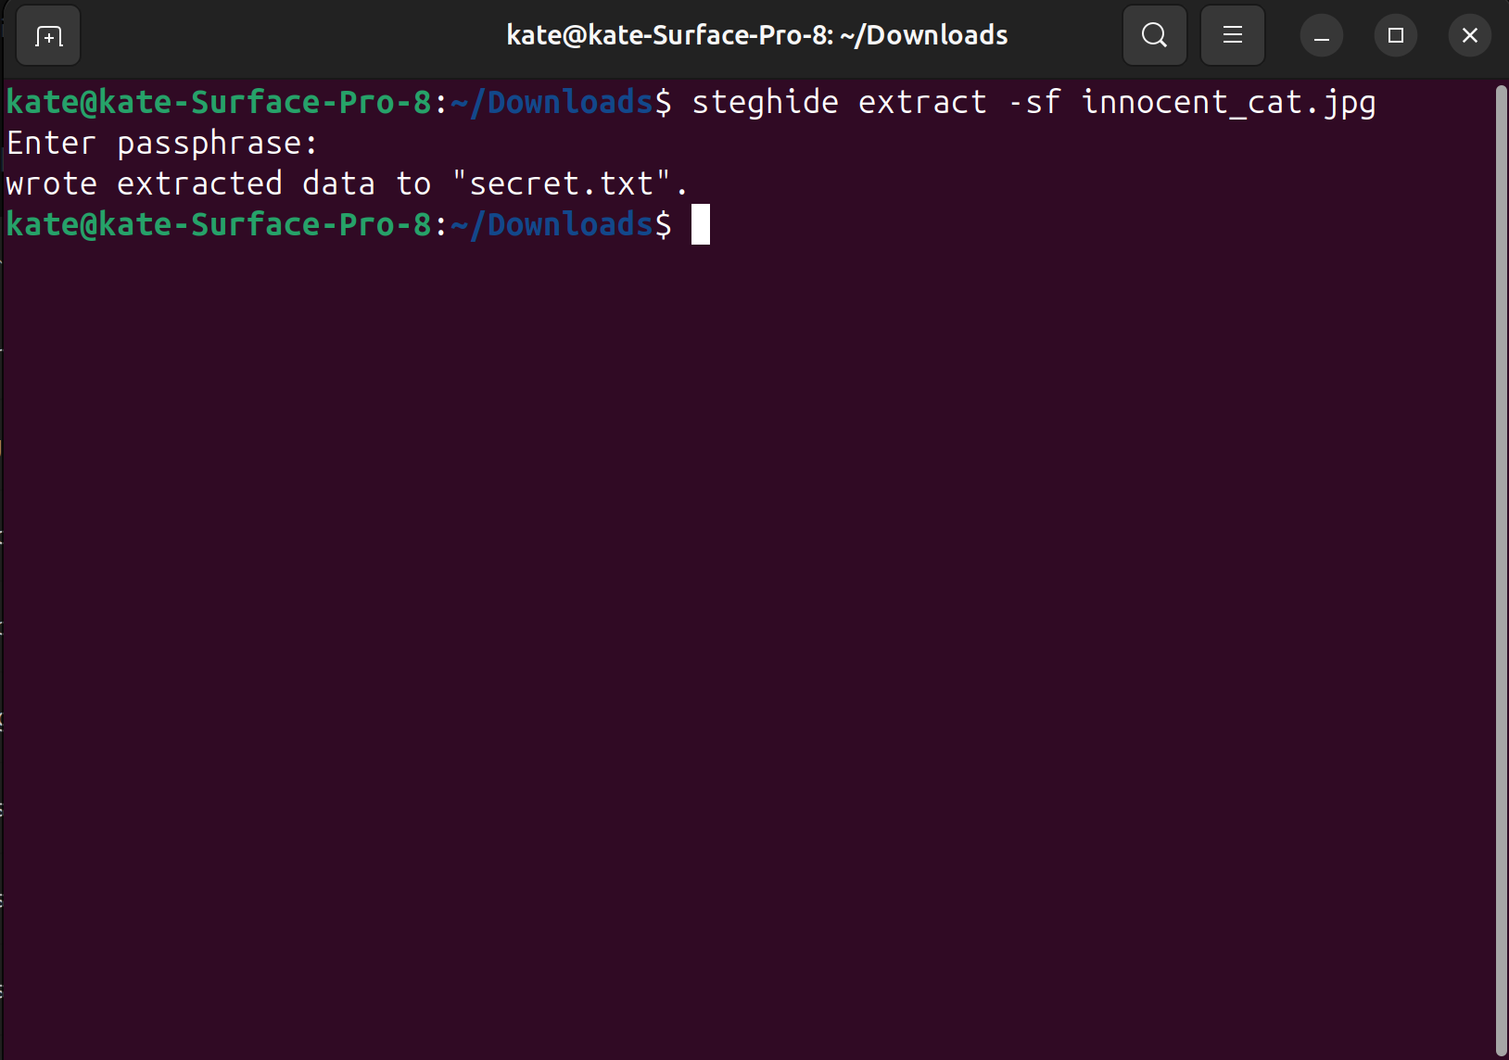

Here is a picture of the file secret.txt.



# 3 Description of Analysis Techniques Utilized

During the hands-on activity, the use of fdisk, dd, and Disk Editor were greatly utilized. Fdisk allowed to analyze the disk to discover the number of partitions on the disk, where each started, and how long they were. dd was utilized to carve out the files onto the device to discover the files. Disk Editor allowed for a detailed analysis of the NTFS partition. It allowed for templates to be applied to sections to simplify the process. Also, the tool steghide was used to discover the hidden file with the innocent_cat.jpg.

# 4 Results and Discussion

The result of the data recovery was 4 files. This reveals Shadow’s location and real name. The location is 7th Brown Ave, Apt #4 and the real name of the criminal is Sean. The final file was hidden inside of the innocent_cat.jpg and revealed this information.

# 5 Conclusions and recommendations

This hands-on assignment challenged the students on their knowledge NTFS partition structure. The basic understanding of the NTFS partition structure was critical to recovering all of the files. I feel like I need more of an understanding of the structure using Disk Editor.

# 6 Acknowledgements

I used Dr. K’s lecture notes to complete this assignment.

# 7 AI Use Statement

As part of this assignment, you are required to explain how Artificial Intelligence (AI) tools were used in your work. For this you need to describe:

* **Purpose of Use** – Formatting of Report and ideas to help analyze the steg
* **Extent of Use** – I used AI to check my grammar of my report. I used AI to research options to discover the hidden file in the steg.
* **My Contribution** – I did not use AI during the part of the assignment when recovering the files.
* **Reflections** – I found that AI caught my errors in my wording and made it flow much better. The AI suggested to use steghide which allowed me to discover the hidden file much quicker.

**By writing this reflection, I acknowledge that AI is a support tool, not a substitute for my own effort, and I take full responsibility for the final submission.**

# 8 References

[1] Hetzl S. 2003. Steghide [Internet]. SourceForge.net; [updated 2003 Oct 9; cited 2025 Oct 3]. Available from: <https://steghide.sourceforge.net/>

[2] Rapid Rables. c2025. Hex to ASCII Text Converter [Internet]. [cited 2025 Oct 3]. Available from: <https://www.rapidtables.com/convert/number/hex-to-ascii.html>